**1. The Data File in Excel or CSV format (3 points).**

Excel file has been uploaded to GitHub.

The following is simply a screenshot of a portion of the dataset:

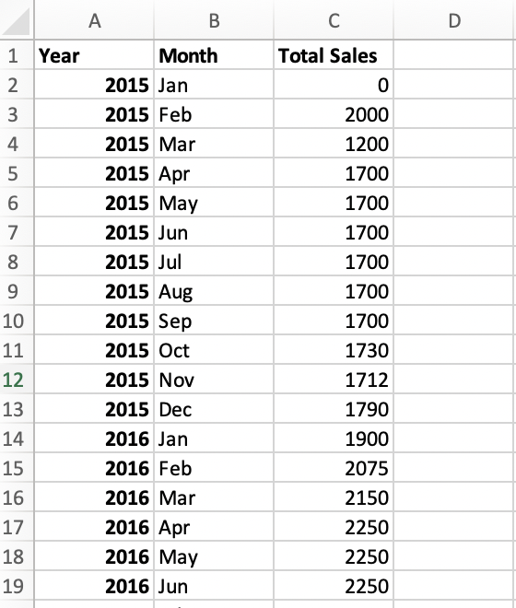

**2. Detailed description of the data. See <https://help.osf.io/article/217-how-to-make-a-data-dictionary>**

**[Links to an external site.](https://help.osf.io/article/217-how-to-make-a-data-dictionary)**

**for ideas on how to create a good data dictionary. (3 points)**

**Dataset Name:** Tesla Monthly Sales Data (2015-2023)

**File type:** Excel file (.xlsx)

**Source:** Goodcarbadcar.net (automotive sales data & statistics). Link: <https://www.goodcarbadcar.net/tesla-inc-us-sales-figures/>

**Description:** This dataset contains Tesla monthly sales data (on a unit basis) from January 2015 to June 2023.

|  |  |  |  |  |
| --- | --- | --- | --- | --- |
| Variable | Variable name | Measurement unit | Allowed values | Description |
| Year | Year | Year (e.g., 2015, 2016) | Integer values representing the year (2015-2023) | The year for which the data is recorded. |
| Month | Month | Month (e.g., Jan, Feb) | Strings representing the month (e.g., Jan for January, Feb for February, ...) | The month in which the data is recorded. |
| Sales | Total Sales | Unit of car | Integer values representing the total sales for the respective month (0-100,000,000) | The total sales for the respective month. |

**3. Data Collection Methodology (2 points). State how the data is collected, by whom, how often, etc.**

It is Tesla’s monthly vehicle sales (on unit basis) in the US from January 2015 to June 2023. The data is collected by Goodcarbadcar.net, and the original data is published by Tesla, and it is collected monthly.

**4. Why does this data set intrigue you? (2 points).**

This data is interesting to me because I know there are more and more people buying electric cars now, and Tesla is definitely the largest company in the industry, so I want to see first what the trend of sales of Tesla is, and if there is any seasonality of the car sales for Tesla.